School Grading System

An Assignment submitted in partial fulfillment of the requirements for the degree of
Bachelor of Science
in
Computer Science

CS 3305: Web Programming 2

Term 4 - 2025
University of The People

Instructor: Shobhit Mani Tewari

April 22 2026

School Grading System

Introduction
The School Grading System demonstrates fundamental programming concepts including arithmetic operations, conditional logic, and loop structures to create a comprehensive student evaluation system. This system addresses the school’s need for automated grade calculation and academic status determination, providing both efficiency and accuracy in academic assessment.

Basic arithmetic operations implementation
The script begins by collecting three exam scores through standard input, utilizing PHP’s fgets(STDIN) function for user interaction (McGrath, 2021). The average score calculation employs the formula ($score1 + $score2 + $score3) / 3, demonstrating basic arithmetic operations with proper rounding for readability. The percentage calculation extends this logic by dividing the total score by 300 (the maximum possible points) and multiplying by 100, providing students with a clear performance metric.
#Output:
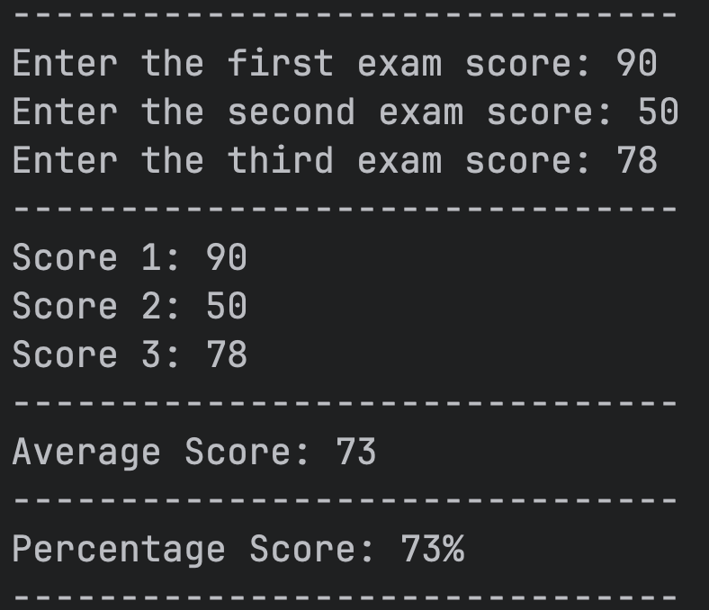

For five-subject evaluation, the system employs an array-based approach to store subject scores using PHP’s array() method (McGrath, 2021). The failure counting mechanism iterates through the $scoreList array, incrementing a counter when scores fall below 50. This implementation efficiently tracks academic standing and triggers appropriate warnings when students exceed two failed subjects, as evidenced by the conditional statement if ($total > 2) that displays the academic probation message.
#Output:
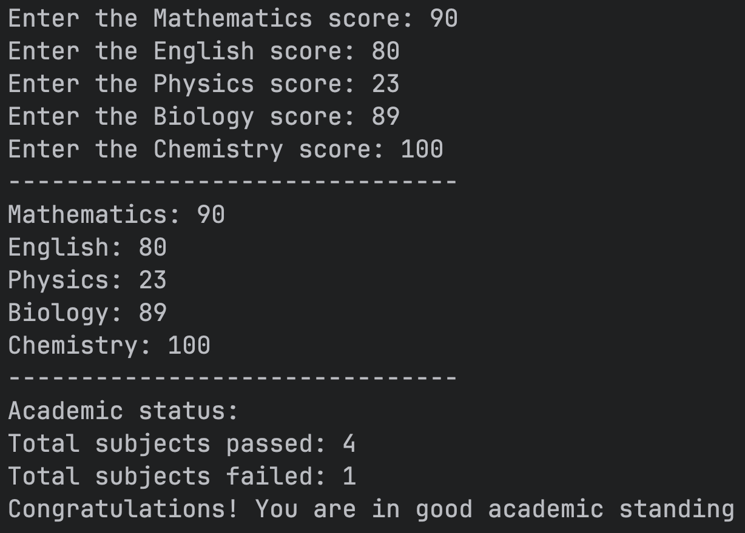

Conditional logic and academic determination
The conditional logic implementation demonstrates sophisticated decision-making capabilities. The pass/fail determination uses a ternary operator ($averageScore >= 50) ? "Pass" : "Fail" for concise evaluation. The Honor Roll qualification combines multiple conditions using logical AND operators (McGrath, 2021), requiring both an average above 90 and at least one score of 95 or higher.

#Output:
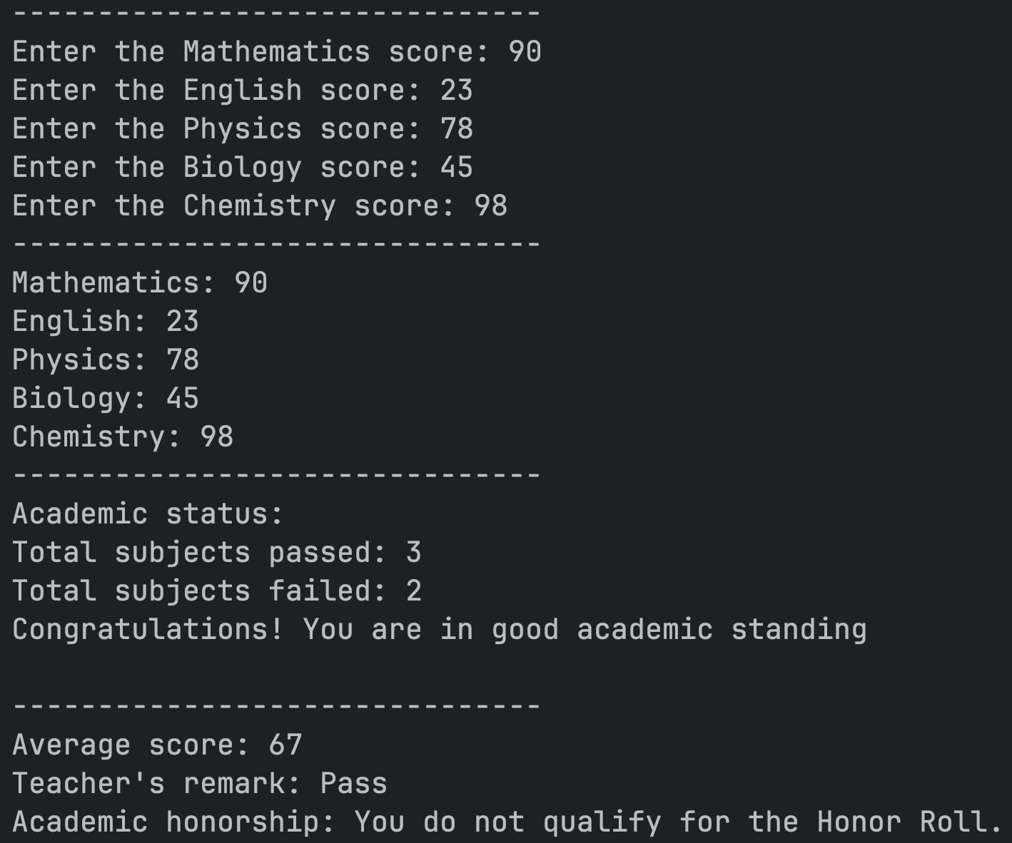

The grade assignment system utilizes PHP’s a comprehensive switch statement with case comparisons (McGrath, 2021), mapping numerical scores to letter grades from A+ to W. This approach provides granular feedback while maintaining code readability. The validation mechanisms ensure data integrity by checking for empty inputs, numeric names, and score ranges between 0 and 100.

Loop structures and batch processing
The grading system features PHP’s nested while loops (McGrath, 2021) to process multiple students efficiently. The outer loop manages student count, while the inner loop handles subject score collection. This structure allows for dynamic course name entry and score validation, creating a flexible grading system that adapts to various course configurations.
The system's error handling prevents invalid data entry through conditional checks, ensuring robust operation. The use of associative arrays ($studentScore[$courseName] = $score) provides meaningful data organization, while the foreach loop facilitates clean grade report generation.
#Output:
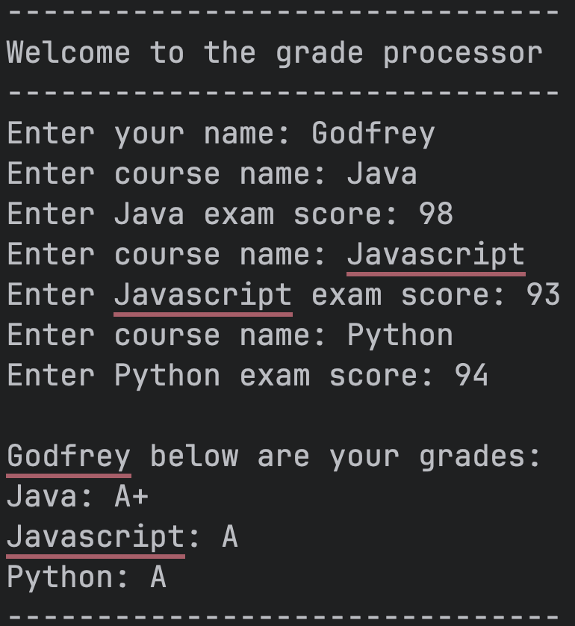
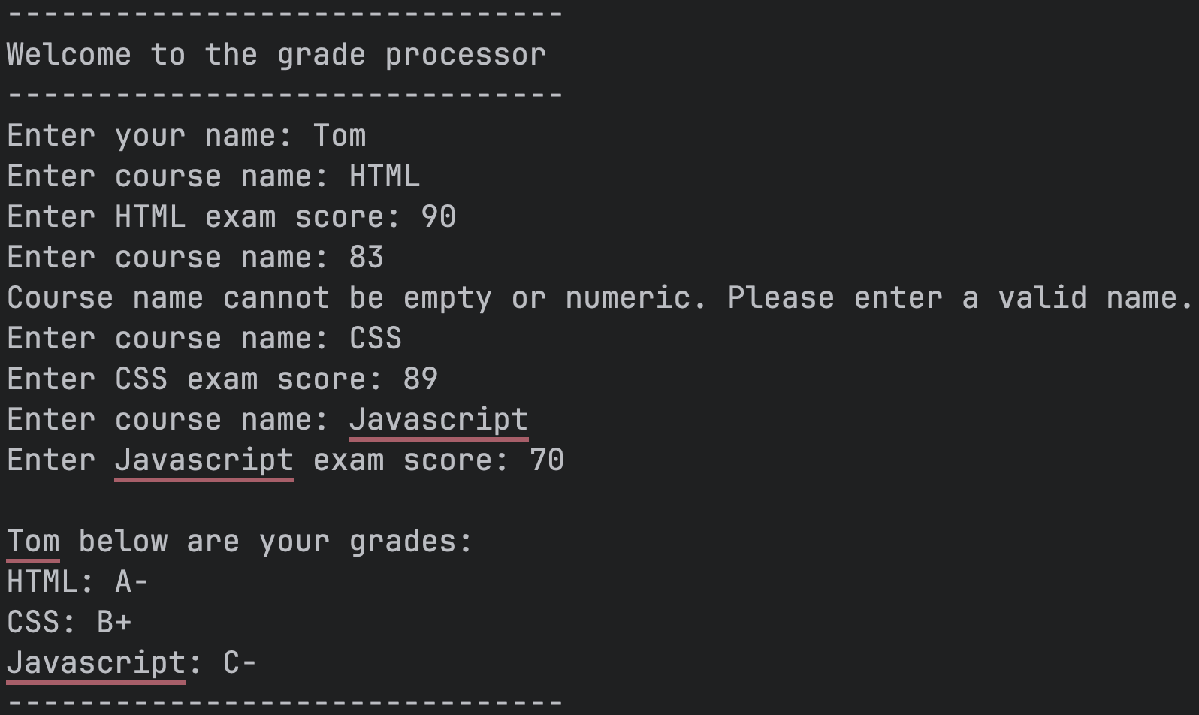

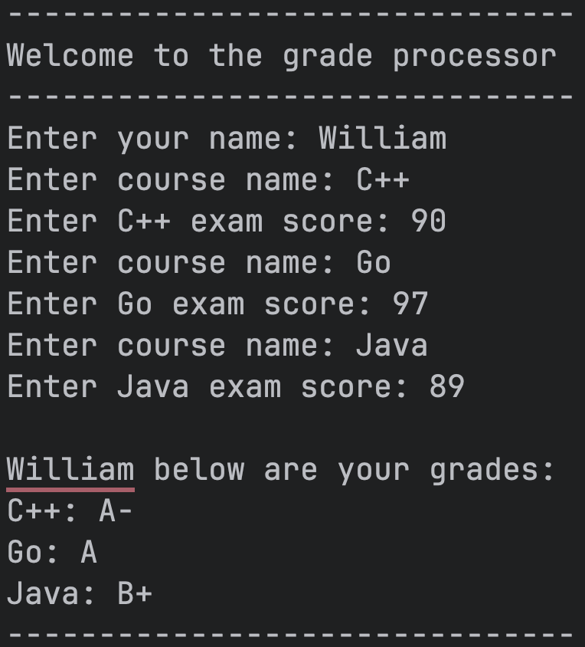
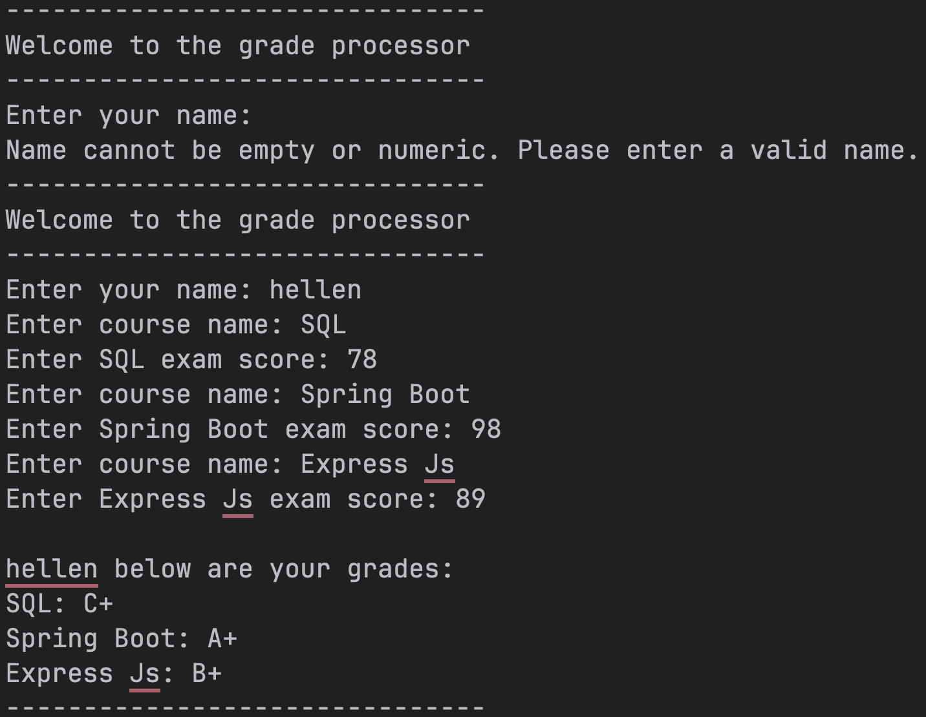

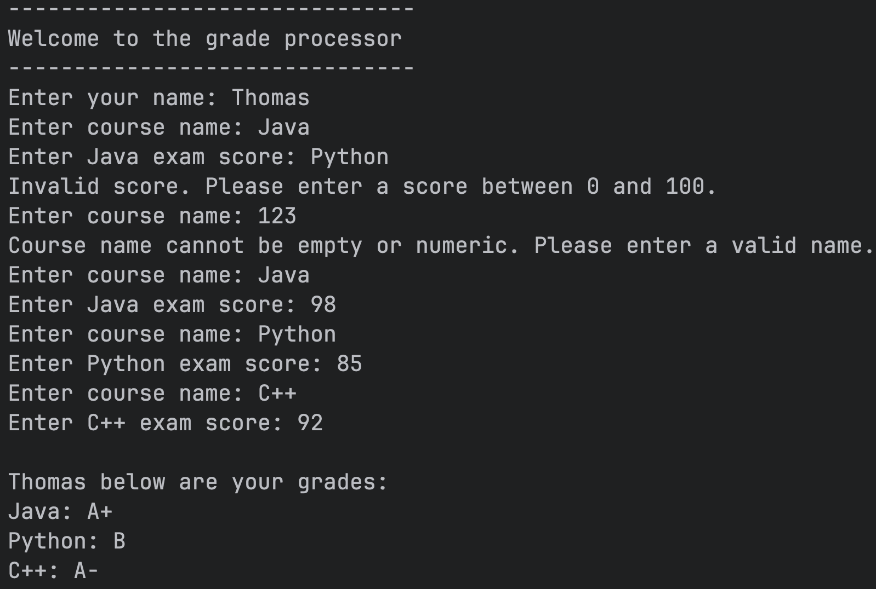

Conclusion
This School Grading System successfully integrates arithmetic operations, conditional logic, and loop structures to create a comprehensive academic evaluation tool. The system demonstrates proper variable naming conventions, modular code organization, and user-friendly interface design. The system effectively addresses the school's requirements while providing extensible architecture for future enhancements, making it a practical solution for automated grade processing and academic status determination.

Reference
McGrath, M. (2021). PHP in easy steps (4th ed.): Updated for PHP 8. In Easy Steps Limited.

